February 2008, and he has been looking after Jenny’s garden ever since. John was able to interpret the recommendations and apply the appropriate treatment to the soil, which then needed to be rested. The ground looked like a desert.

In May 2008 the first plant went into the soil. It was a tree fern from Jenny’s St Ives home, and was followed by a number of newly-purchased plants. The correction of the soil resulted in all the new plantings growing strongly and looking wonderfully healthy.

The next month a vegetable patch was started, Sasanqua camellias were planted and espaliered along a fence, and more garden beds and walls were built.

It was not until the end of July that the rescued plants were brought down from Mt Victoria. The rescue work at St Ives had taken place on the last day of July 2005, and the transfer to Jenny’s Wentworth Falls property occurred three years later on the last day of July 2008. This was a perfect time for the deciduous plants to be transplanted. Jenny explained that it was just as if you would pick up a sleeping baby, undisturbed by movement and the plants would wake up peacefully in a new bed. In August the maples showed signs of life in their new home. Only one maple did not survive the double move.

Now Jenny and John have created what is a delightfully pleasing and peaceful “stroll” garden.

Jenny keeps a garden diary. The diary, the Australian Botanical Illustrations Perpetual Diary by Dr Helen Hewson, was a gift which she requested with this purpose in mind. As a reference, Jenny also keeps a small photo album in which she places the labels from her plants.

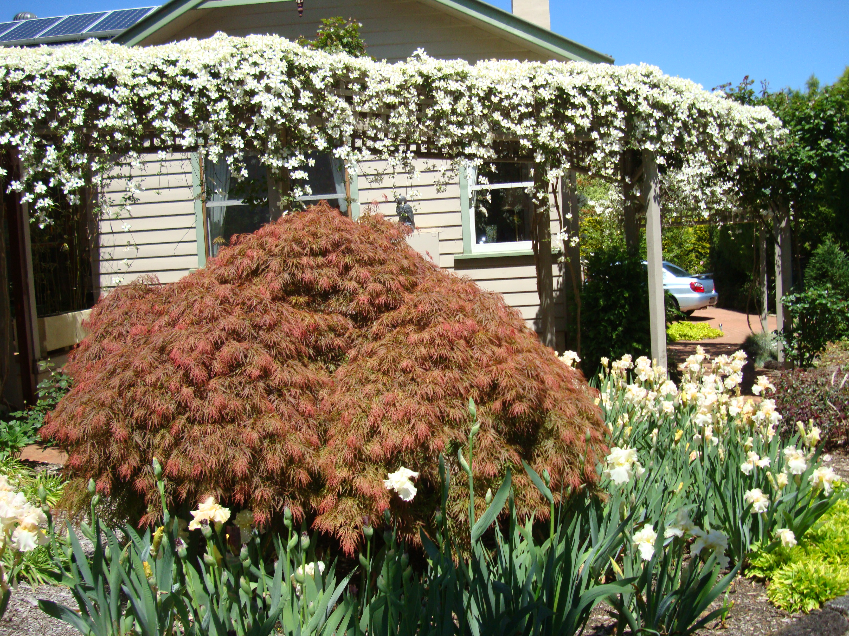

One of the old maples growing in front of the arbour covered in clematis

Jenny has observed that the major difference between her garden in St Ives and her Wentworth Falls garden is the change in seasons. Here, there are four distinct seasons, and when the plants are treated accordingly they respond to each season differently and beautifully. Jenny finds this a delight.

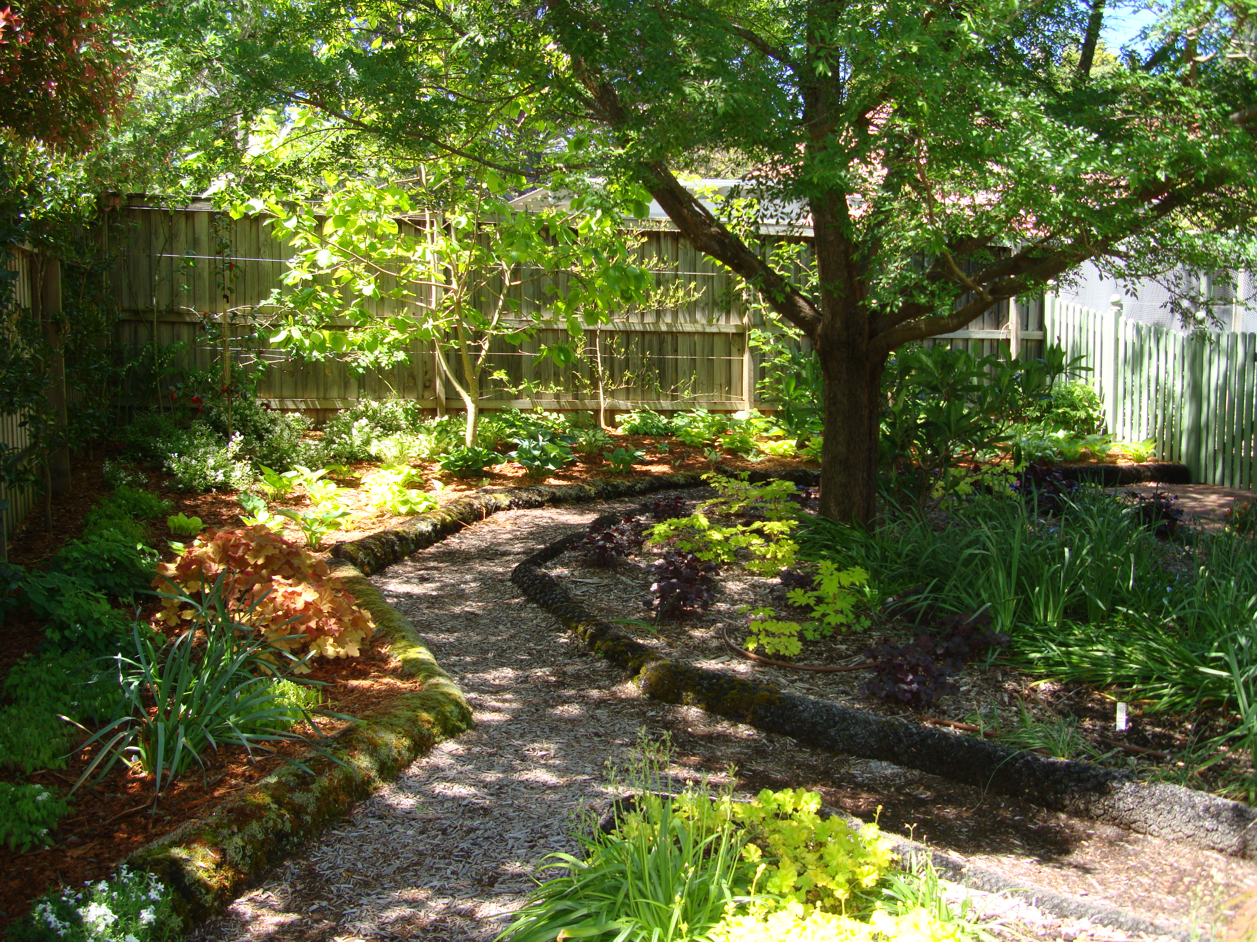
The Chinese elm in this picture is six years old. It’s rapid growth and maturity can be attributed to the correction of the soil.

