

10 January 2013 Edition No. 256
FromThe President…….
Today we are seeing our first newsletter produced by our new Publicity Officer. Thank you for the work that you have put into it, Narelle!

This year is going to be a busy year for the club. As well as our regular monthly meetings, we look forward to our participation in the 1813 Crossing seminars being run here on April 13, with 5 top-line special speakers. We will hear lots more about this from today.
Unfortunately our application for a Government Grant to purchase a data projector was rejected and so your committee is looking for ideas on how we can raise funds for this. It is necessary for us to have our own if we are to attract the high quality speakers and presentations that we are used to at our meetings.

Good Gardening,
Henry


.

Ron Keen won
1st prize.
Sylvia Beresford’s
original
botanical artwork

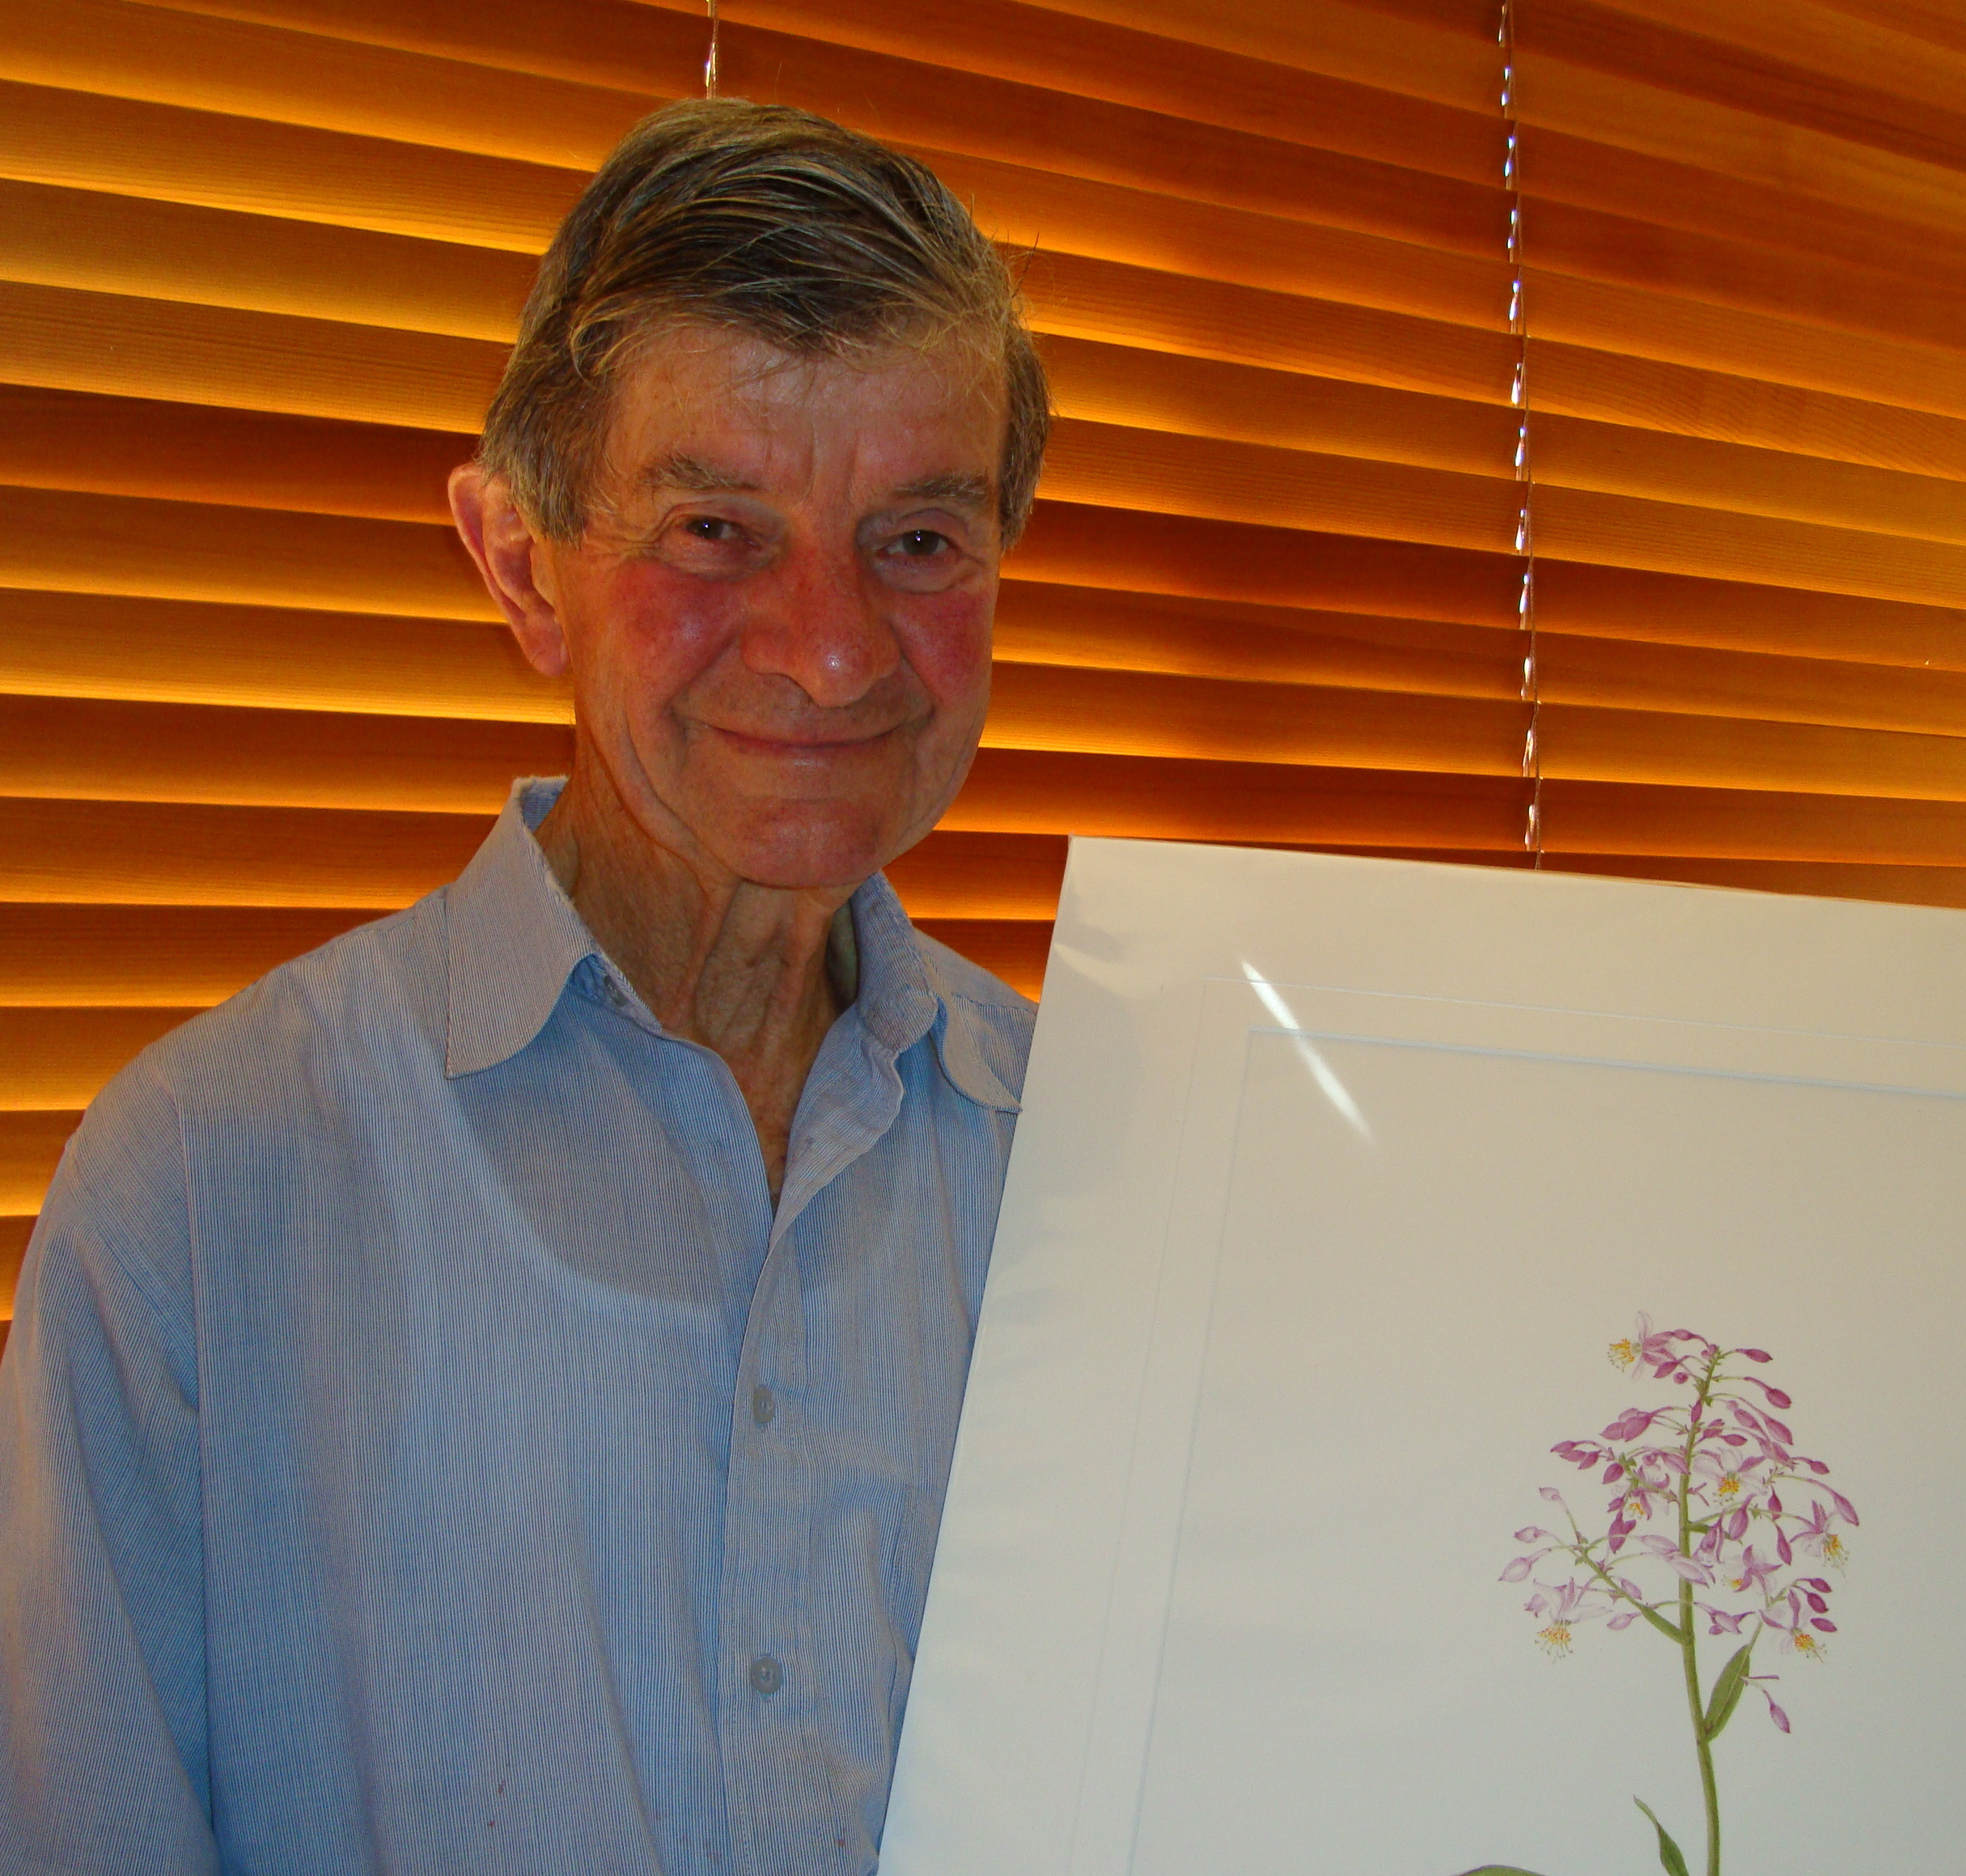
Jennifer Wigan, Julie Allen, Les Allen and Peter Shoemark, enjoying the Garden Club Christmas party



Special Thank You to Sylvia Beresford ………

Sylvia, who now resides in Wentworth Falls, retired some years ago after a very successful commercial career. Once retired, she tried her hand at botanical art, initially with the idea of having paintings to adorn the walls of her new home but her creative talent led her into a wider world of botanical art that has brought accolades and great success. Sylvia is now a member of the Royal Botanical Art Society and her work is exhibited at the Sydney Botanical Gardens and The Royal Art Society of NSW. Her work can also be found in private collections in Australia, Canada, UK, USA, Sweden and France.

For a number of years Sylvia generously donated her works of art to the garden club as raffle prizes. As she will be pursuing her art with much vigour, 2012 was the final year for such kind generosity. We wish her well in her artistic endeavours but it is very pleasing to know she will still regularly attend garden club meetings.

Thank you Sylvia for your time and generosity from all at Wentworth Falls Garden Club.
Sylvia Beresford
Botanical Artist
Vegies to Plant in January
Beetroot, Celery, Leek, Pea Bounty, Sugarpod, Spring onion, Broccoli, Brussel Sprouts, Cabbages, Cauliflower, Chives, Lettuces, Pak Choi, Silverbeet, Spinach and Oriental combo
 Dates for Your Diary
Friday  8 Feb | Up Hill & Down Dale | We will visit beautiful Hillandale at Yetholme. Cuppa on arrival, a leisurely stroll along the gorgeous summer borders. We’ll then head back to the shady verandah for a tasty lunch. Sarah, our host, has plants for sale, all perfect for the mountains. We will then drop into Bill’s at Mt Victoria for another chance to buy, then home. | Cost  $30 | Depart WF at 9am  (will be Blackheath pick up)
Friday  15 March | A Double Delight Day of Roses | We will tour a delightful rose farm and have lunch. Further details soon. | TBA | TBA
Saturday  13 April | Bilpin Plant Fair | We will attend Bilpin Plant Fair (to be held at Clarendon Racecourse in 2013) with the opportunity to purchase some exciting plants. Then relax with lunch on the way home. | TBA | TBA
Friday  12 July | The Charm of Camellias | A tour of a garden full of beautiful camellias. Lunch then home. More details soon. | TBA | TBA

Guest Speakers
Today’s Meeting
10 January 2013

Next Meeting:
14 February:

Megan Halcroft
Bees (see information sheet)

Dominic Wong
Peony Gardener from the Southern Highlands will discuss growing Peonies

Club Information

All members and visitors are asked to sign in upon arrival.

Members are asked to wear their club name badges to all club meetings, tours and functions. To take part in club functions and tours you must be a bona-fide club member

General Meetings are held on the 2nd Thursday of each month, from January to November at the Wentworth Falls School of Arts Theatre, Adele Ave (cnr Great Western Hwy) Wentworth Falls. Meetings commence at 9.45 and finish around noon. The Library and plant Stall are open before the meeting and at morning tea.

 Morning Tea

Today: Monica Foltin and Inge Mayer

14 Feb: Silva Ikaunieks and Vivien Jones

If you are unable to come on your rostered day, please call Jane Blackshaw on 47572887
Wentworth Falls Garden Club
PO Box 37
Wentworth Falls NSW 2782
www.wentworthfallsgardenclub.com

Club Secretary: Janice Light
Tel: 4782 2481

