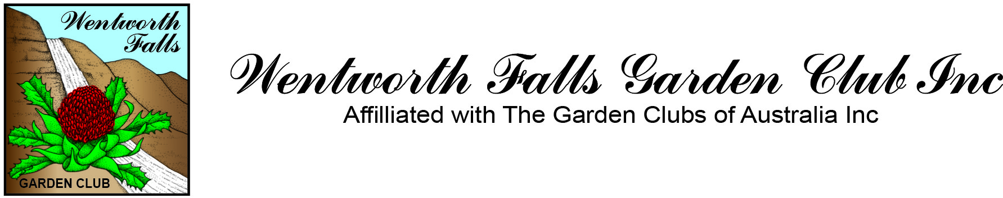

Guest Speaker Megan Halcroft , Bee Keeper 10 January 2013

A bit about Megan

After a career change from nursing, Megan successfully completed her degree in horticultural science in 2004. This included a unit in Apiculture (honey bee keeping), one of Megan’s favourite subjects. She was fortunate enough to be offered an Honours project in 2006, studying one of our many native bee species, Austroplebeia australis. Her love for this bee species, and many others, grew during her studies. In 2008, she commenced her PhD, studying the biology, behaviour and phylogeny of A. Australis, as a potential alternative crop pollinator. Megan has only recently completed her PhD and is now trying to share her passion for Australian native bees. As a local Blue Mountains resident, her goal is to increase local community awareness about our native bees, and to improve conservation through education.
She will be talking about some of the bee species found in the Sydney and Blue Mountains region. She will share with you ideas on how to conserve natural populations and also how to provide additional nesting habitat to help increase populations in your area.
Megan will have some artificial nests available to purchase on the day and they are priced at $50 each. You can also see how to make them yourself at her website www.beesbusiness.com.au

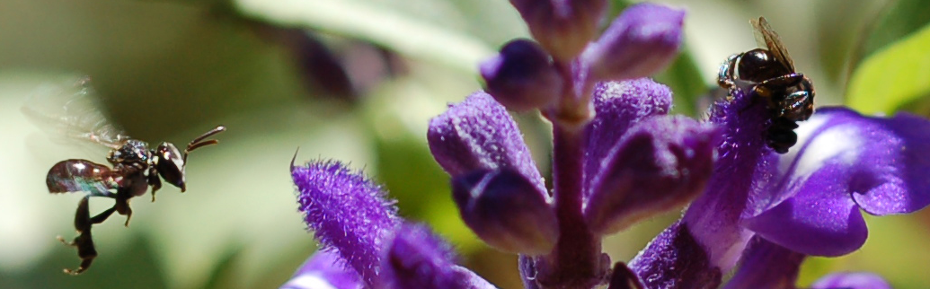

Tetragonula Carbonaria Salvia

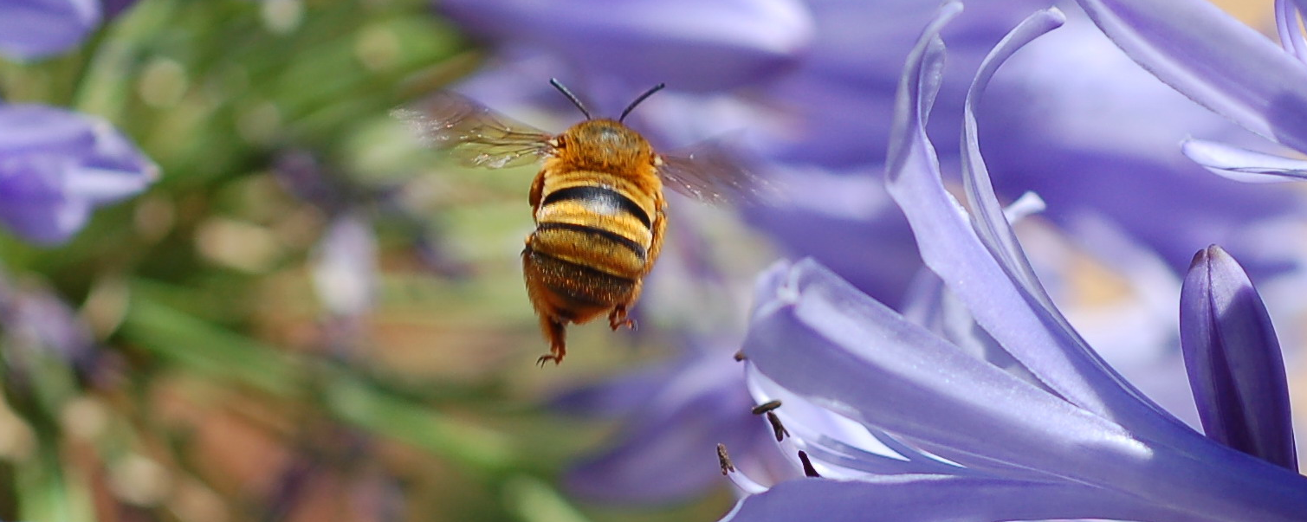

Teddy Bear Bee …..grooving

