Celeste Shadie’s worm farm

When Celeste decided to start a worm farm she researched the subject and spoke with an experienced friend to find out what was required. Celeste bought her worm Farm from Home Hardware and her worms from Longview Nursery. The cost was $89 and $50 for the worms. Since Celeste made her purchase, Celeste noted that Aldi started selling them for around $50 – always the way!!!!

The process starts in the kitchen with a beautiful silver pot in which Celeste keeps suitable vegetable scraps to feed her hungry worms. Some vegetables, like an apple core, she chops, so the worms process it quickly. She doesn’t add meat, citrus, bread or anything from the onion family. She keeps banana skins, not for the worms, but to put around her very successful roses. I also noticed egg shells and tea bags beside the sink. Celeste said that those go in the compost, but not other vegetables. Rats can be a problem in the compost.

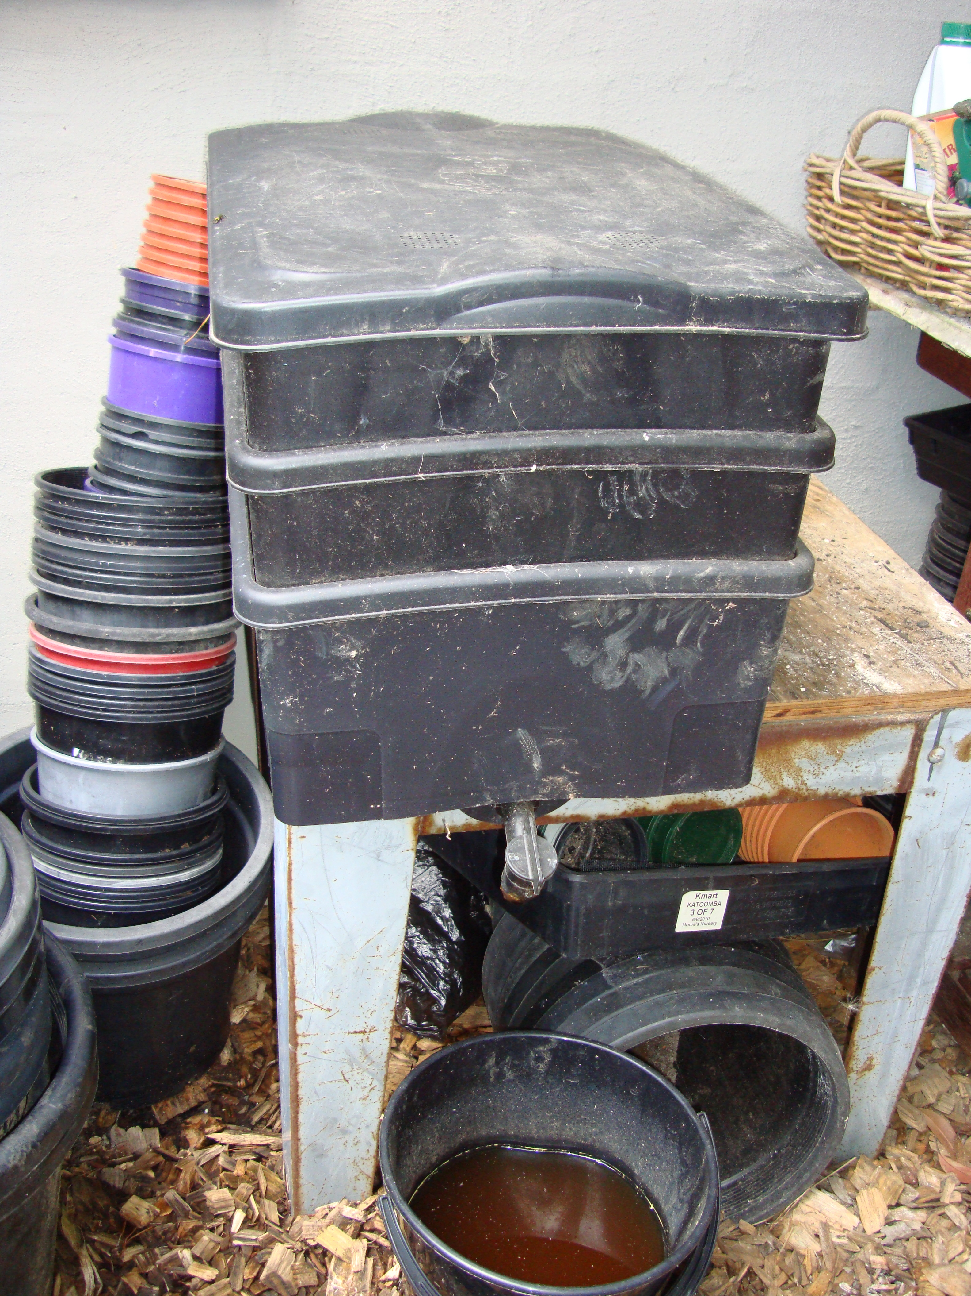
Downstairs, in a little courtyard stands the worm farm next to the compost bays and a table with garden equipment on it. Importantly, the worm farm is in shade and not direct sunlight. The worms also have some protection from rainfall. The worm farm has a bottom tray and a lid. There are another 2 trays available which can be added as tiers, if needed. The clever little worms travel up through the holes between trays to get food.

Their castings (poo) accumulate in the bottom tray when the worms eat the vegetables over time.

Every couple of weeks, Celeste adds a handful of dolomite lime and a handful of potting mixture to the top tray. If the mix becomes smelly or there are flies around, Celeste adds additional dolomite lime to sweeten the mix.
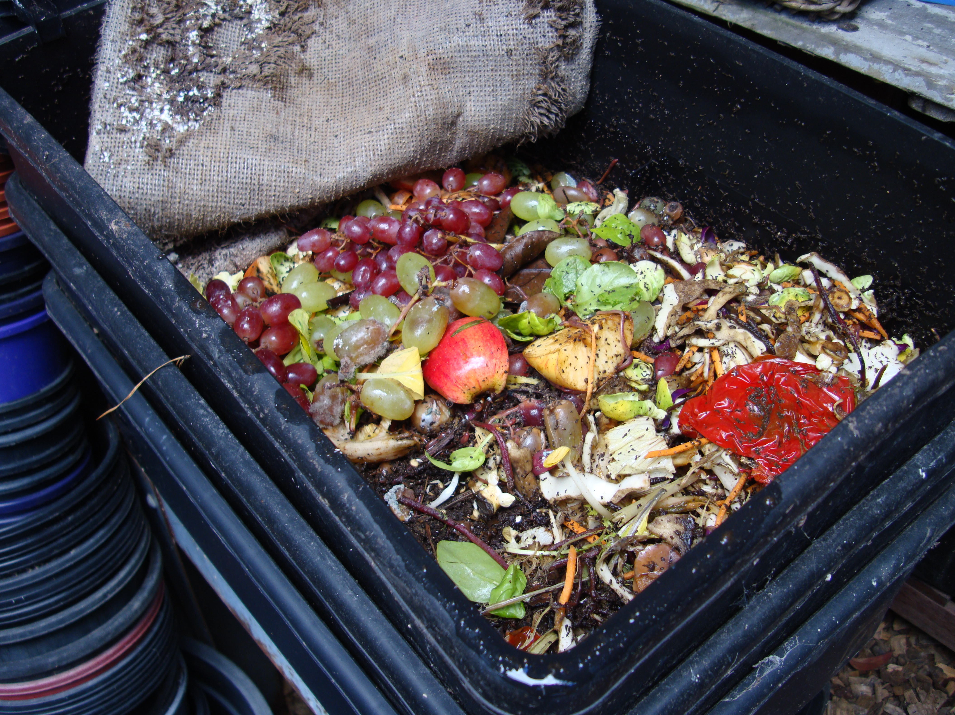

When establishing her worm farm, Celeste started out by providing only a small amount of food for the worms allowing them time to multiply.

Celeste keeps a square of damp carpet on top of the worms and their food within the container. This keeps the worms cool and protected.

When harvesting the worm castings from the bottom tray, Celeste puts on her gloves and sifts through the castings to take out any worms that are in the castings. Celeste tells me that unfortunately, the worms will not survive in the garden. They are a special species of worms, unlike earth worms.

As the castings are very rich, a tray of castings goes a long way in the garden. Small portions of the castings are scattered around the base of plants. Celeste uses the castings mainly in her vegetable garden.

As well as casting in the bottom tray, worm wee drops down through an open tap attached to the plastic bottom tray into a bucket. This can be used as a fertiliser around plants at a rate of 1 part worm wee to 10 parts water. It should look like weak tea.

I could see that Celeste loves her worm farm. She states that this is a great way to recycle kitchen waste.

Thank you Celeste for sharing your worm farm process with the Garden Club

